Exercise: 1
Software Development Life Cycle:

A software life cycle model (also termed process model) is a pictorial and diagrammatic representation of the software life cycle. A life cycle model represents all the methods required to make a software product transit through its life cycle stages. It also captures the structure in which these methods are to be undertaken.

In other words, a life cycle model maps the various activities performed on a software product from its inception to retirement. Different life cycle models may plan the necessary development activities to phases in different ways. Thus, no element which life cycle model is followed, the essential activities are contained in all life cycle models though the action may be carried out in distinct orders in different life cycle models. During any life cycle stage, more than one activity may also be carried out.

SDLC Cycle represents the process of developing software. SDLC framework includes the following

The stages of SDLC are as follows:

Stage1: Planning and requirement analysis

Requirement Analysis is the most important and necessary stage in SDLC.

The senior members of the team perform it with inputs from all the stakeholders and domain experts or SMEs in the industry.

Planning for the quality assurance requirements and identifications of the risks associated with the projects is also done at this stage.

Business analyst and Project organizer set up a meeting with the client to gather all the data like what the customer wants to build, who will be the end user, what is the objective of the product. Before creating a product, a core understanding or knowledge of the product is very necessary.

For Example, A client wants to have an application which concerns money transactions. In this method, the requirement has to be precise like what kind of operations will be done, how it will be done, in which currency it will be done, etc.

Once the required function is done, an analysis is complete with auditing the feasibility of the growth of a product. In case of any ambiguity, a signal is set up for further discussion.

Once the requirement is understood, the SRS (Software Requirement Specification) document is created. The developers should thoroughly follow this document and also should be reviewed by the customer for future reference.

Stage2: Defining Requirements

Once the requirement analysis is done, the next stage is to certainly represent and document the software requirements and get them accepted from the project stakeholders.

This is accomplished through "SRS"- Software Requirement Specification document which contains all the product requirements to be constructed and developed during the project life cycle.

Stage3: Designing the Software

The next phase is about to bring down all the knowledge of requirements, analysis, and design of the software project. This phase is the product of the last two, like inputs from the customer and requirement gathering.

Stage4: Developing the project

In this phase of SDLC, the actual development begins, and the programming is built. The implementation of design begins concerning writing code. Developers have to follow the coding guidelines described by their management and programming tools like compilers, interpreters, debuggers, etc. are used to develop and implement the code.

Stage5: Testing

After the code is generated, it is tested against the requirements to make sure that the products are solving the needs addressed and gathered during the requirements stage.During this stage, unit testing, integration testing, system testing, acceptance testing are done.

Stage6: Deployment

Once the software is certified, and no bugs or errors are stated, then it is deployed.Then based on the assessment, the software may be released as it is or with suggested enhancement in the object segment. After the software is deployed, then its maintenance begins.

Stage7: Maintenance

Once when the client starts using the developed systems, then the real issues come up and requirements to be solved from time to time.This procedure where the care is taken for the developed product is known as maintenance.

What are agile methodologies?

The first we heard about Agile development (or the term Agile) was back in 2001 when a community of developers that had grown tired of using development methods considered to be “heavy” – namely, the waterfall model – decided to set out a manifesto: The Agile Manifesto. This very important document had so much impact that it has worked as a bible for Agile development even until today, laying out all principles and good practices.

Agile methodologies argue that, above all, we should seek client satisfaction through the continuous delivery of value-adding software, by staying in constant communication with the client, and also by focusing on communication between team members. Contrary to previous practices, Agile methodology is not characterised by the complete definition of a product, but rather “step by step” – a complete analysis or the definition of all categories/requirements, by dynamic interaction that allows constant delivery
- Focused on “near-shore” visibility but never losing the long-term product goal.

Customer satisfaction is the top priority, demonstrated through continuous delivery and added value.

Changes to requirements should be accepted – rather than pursuing “rigid” requirements, even if at a late stage in development: “Agile processes harness change for the customer’s competitive advantage”, as is stated in the Manifesto.

The customer and the development team should work together on a daily basis, facilitating team and product synchronisation.

It is vital to provide a pleasant environment and good support to development teams. Only in this way is it possible to keep them motivated.

Agile processes promote sustainable development due to their constant rhythm and technical excellence, which in turn improves productivity.

Retrospective moments inside a team are essential, allowing it to make the necessary adjustments and promote efficiency.
Basically, Agile development follows an incremental model, which develops collaboration within the team and continuous planning, as well as everlasting evolution and learning. Agile methodologies should respect the software development cycle – planning, execution and final delivery – therefore allowing software to be developed in stages; this makes it easier to identify and resolve bugs or new needs.

The main advantage of using Agile methodologies is not just the fast delivery of software, but also the constant delivery of “value” to the customer, since deliveries are incremental.

There are countless methodologies that follow this Agile mindset. In this blog post, we highlight the five main Agile methodologies and their advantages and disadvantages in the software development universe. But we cannot dive into the different methodologies without first referring to the growing popularity of the Agile methodologies (or some of them at least) with business management. This proves that is just not software development that can be enriched using these practices.

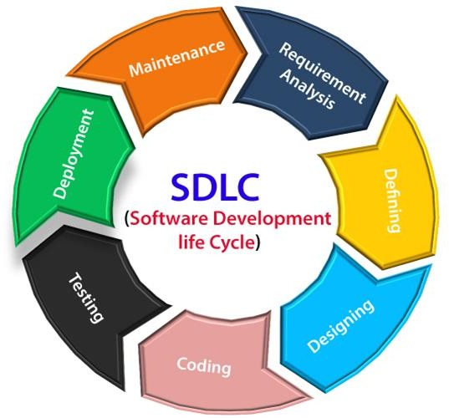
Business development is becoming an increasingly unpredictable playground, just like software development. So the challenge is now why not implement Agile methodologies in business process management? Agile methods are adaptable, allowing for rapid decision- making and instant influence on business development.

4 values of Agile Manifesto
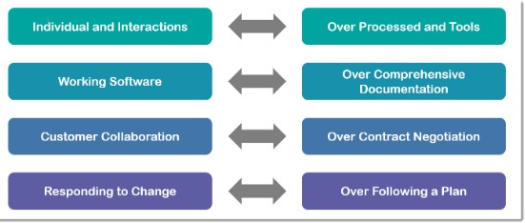

Main Agile methodologies:

- Scrum

Scrum is, undoubtedly, the most used of the many frameworks underpinning Agile methodology. Scrum is characterised by cycles or stages of development, known as sprints, and by the maximisation of development time for a software product towards a goal, the Product Goal. This Product Goal is a larger value objective, in which sprints bring the scrum team product a step closer.

It is usually used in the management of the development of software products but can be used successfully in a business-related context. Every day starts with a small 15-minute meeting, the daily Scrum, which takes the role of synchronising activities and finding the best way to plan out the working day, allowing for a check on sprint “health” and product progress.

2.kanban

The word Kanban is of Japanese origin and its meaning is linked to the concept of “just in time”. In practice, the Kanban method is organised on a board or table (Kanban board), divided into columns, showing every flow within the software production project. As the development evolves, the information contained in the table changes, and whenever a new task comes into play, a new “card” is created.

This methodology is also useful in individual business departments, such as HR, marketing, etc., bringing the desired visibility over all the team’s tasks.

The Kanban method requires communication and transparency so that the members of any team all know exactly what stage development is at and can see the status of a project at any time. It primarily focused on team capacity and is best for processes that undergo small changes.

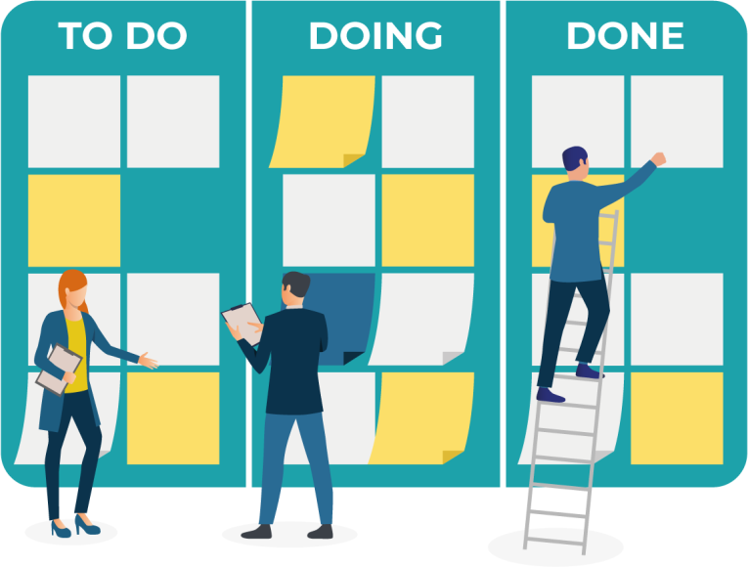

Extreme Programming (XP)

This is a typical Agile development framework, developed by Kent Beck, and can be adapted to development companies of various dimensions.

Extreme Programming (“XP”) methodology is based around the idea of discovering “the simplest thing that will work” without putting too much weight on the long-term product view. It is a methodology that emphasises values such as Communication, Simplicity, Feedback, Courage and Respect, and prioritises customer satisfaction over everything else. This methodology encourages trust by motivating developers to accept changes in customer requirements, even if they arrive during the latter stages of the development cycle.

Teamwork is extremely important in XP, since, when there is a problem, it is solved by the whole team of managers, developers or customers, bringing them together to promo
conversation and engagement and break down barriers to communication. They all become essential pieces of the same puzzle, creating a fertile environment for high productivity and efficiency within teams. In Extreme Programming, the software is tested from day one, collecting feedback to improve development. XP promotes activities such as pair programming, and with a strong testing component, it’s an excellent engineering methodology.

Cockburn, “Crystal is a family of software development methodologies, which works with the power invested by people, and is extremely light and stretch-to-fit”. Basically, Cockburn believes that talent and the way team members interact brings benefits for the whole project.It’s a light methodology in terms of documentation, where teams can find their own ways over preferred work modalities, removing management overheads and creating a “free” process.
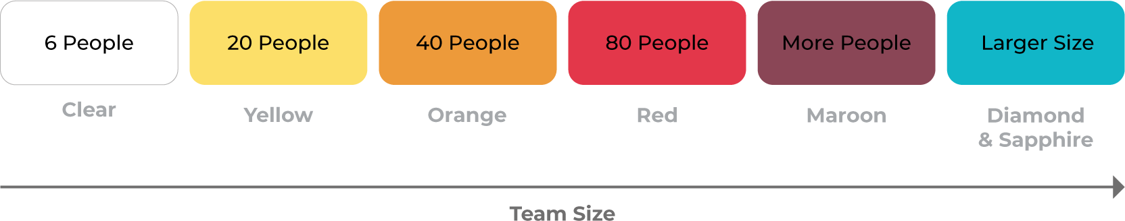

Exercise: 2

Extreme Programming XP Practices

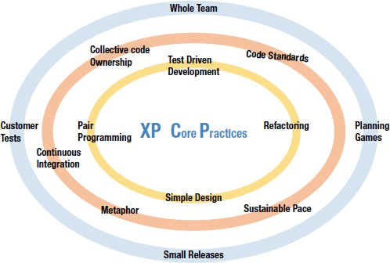

Planning Game

In XP the main planning process is called Planning Game. There are 2 levels of plans in XP; level one is release planning and level 2 is iteration planning.

In both levels, there are 3 steps: exploration, commitment, and steering.

The first phase is release planning. The team and stakeholders/customers collaboratively decide what are the requirements and features that can be delivered into production and when. This is done based on priorities, capacity, estimations and risks factor of the team to deliver.

In Iteration planning the team will pick up the most valuable items from the list and break them down into tasks then estimates and a committment to delivering at the end of the iteration.
Simple Design

In the XP, the team will not do complex or big architecture and designs upfront; instead the team will start with a simple design and let it emerge and evolve over a period of iterations. The code is frequently refactored so that it will be maintainable and free of technical debt. Simple designs make the 'definition of done' easier.

XP teams conduct a small test or proof-of-concept workout called spike. The outcome of the spike helps the team to apprehend the validity of the hypothesis, gauge the complexity of the solution and feel assured to estimate and build something primarily based on the test.

Test-Driven Development (TDD)

In XP Developers write the unit test cases before starting the coding. The team automates the unit tests and it helps during the build and integration stage. The main benefit of TDD is that programmers have to only write the code that passes the tests.

Basics steps of TDD,
    - Write the unit test case first
    - Write a minimal amount of code to pass the test.
    - Refactor it by adding the needed feature and functionality, While continuously making sure the tests pass.
Code Standard

Organizations want their programmers to hold to some well-described and standard style of coding called coding standards. It is a guideline for the development team as in XP. Since there are multiple programming pairs at play coding standards are very useful to make consistency in code, style, naming conversion, exception handling and use of parameters.

These standards must define and agreed before the team starts the coding.

It will make the code simple to understand and helps detect the problem or issues quickly and also increases the efficiency of the software.
Refactoring

Refactoring as the word suggests, is restructuring or reconstructing existing things. In XP over a period of time the team produces lots of working code and it increases the complexity and that contributes technical debt. To avoid this, we should consider the below points,
    - Ensure code or functions are not duplicated.
    - Ensure all variables in scope, defined and used.
    - No long functions or methods
    - Removing unnecessary stuff and variables
    - Proper use of access modifiers etc.
By refactoring, the programmers look to improve the overall code quality and make it more readable without altering its behavior.

Pair Programming

This is my favorite and most used practice. Pair programming consists of two programmers operating on the same code and unit tase cases, on the same system (one display and one keyboard). One programmer plays the pilot role and focuses on clean code, and compiles and runs. The second one plays the role of navigator and focuses on the big picture and reviews code for improvement or refactoring.

Every hour or given a period of time this pair is allowed to switch roles so that the pilot will play the role of navigator and vice versa.

The pairs of pilots and navigators are also not fixed and they are frequently swapped, the main benefits of that over a period of time is that everyone gets to know about the code and functionality of the whole system.

Collective Code Ownership

By following pair programming practices the XP team always takes collective ownership of code. Success or failure is a collective effort and there is no blame game. There is no one key player here, so if there is a bug or issue then any developer can be called to fix it.
Continuous Integration

CI is Continuous Integration. In XP, Developers do pairs programming on local versions of the code. There is a need to integrate changes made every few hours or on a daily basis so after every code compilation and build we have to integrate it where all the tests are executed automatically for the entire project.

If the tests fail, they are fixed then and there, so that any chance of defect propagation and further problems are avoided with minimum downtime.

The team can use CI tools like Jenkins, shippable, Integrity, Azure DevOps Pipelines, etc. Small Release
A cross-functional team in XP, releases Minimum Viable Product (MVP) frequently. Small releases also help to breakdown complex modules in a small chunk of code. This helps the developer team as well as the on-site customer to demonstrate the product and focus only on the least amount of work that has the highest priority.

System Metaphor

This is majorly connected with the user story, the story must be simple enough to be easily understood by user and developers and to relate it with code.
It could be a naming conversion practice used in design and code to have a shared understanding between teams. For example Order_Food() is easily explained -- this will be used to order food.

eXtreme Programming (XP) –Key Practices
eXtreme Programming (also known as “XP”) is one of the most popular software engineering methods originally introduced in the 1990’s. While many organizations have chosen to utilize “Agile” or “Scrum” as the main buzzword today to describe iterative and incremental development, XP seems to have become less and less understood over the past few years. Many organizations have come to assume that “XP” is synonymous with pair-programming, which not entirely accurate; pair-programming may have become one of the main distinguishing characteristics of XP, but it is only one of the twelve practices that this methodology encompasses. So which of these practices are still important and relevant today? Let explore a few.

Key Practice #1 – Pair Programming

One of the most unique traits of XP is the practice of pair-programming, where two (and possibly more) engineers work side-by-side to develop code together. This approach is designed to optimize quality due to the built-in validation mechanism that is expected between two engineers which contribute to a single unit of code. While some organizations embrace this technique, this approach will require careful selection of partners to ensure maximum effectiveness. Culturally, there may also be a need to educate leadership folks who may not understand the value and see this as increased overhead/cost.

Key Practice #2 – Planning Game

XP receives credit for introducing a different approach to planning work through planning small batches of work frequently and through a consistent schedule. This was a precursor to what many of us know as “Sprint Planning” or “Iteration Planning” today within Scrum or other Agile approaches. Planning iteratively and applying a popular technique called “user stories” is one of the most important aspects of XP that has trickled down to Scrum, the most popular Agile method in the world today.

Key Practice #3 – Continuous Process

The practice of integrating code regularly and releasing the code on a cadence has been recently popularized by the movement also known as “DevOps” which originated the XP practices. Building code iteratively and releasing frequently enables the team to assess state of the product and resolve issues as early and often as possible which ultimately leads to higher overall quality in the end.

Key Practice #4 – Coding Standards

One of the most important and often forgotten practices amongst new Agile teams is the concept of coding standards. If a team of engineers do not construct a common set of rules, the end product will suffer a lack of consistency and increase the likelihood of technical debt as well as defects.

Key Practice #5 – Sustainable Pace

One of the key tenets of Agile Manifesto is to respect work-life balance for teams and encourage sustainable development, which enhances morale as well as product quality. XP reinforces this value in order to maximize team effectiveness.

Key Practice #6 – Test Driven Development ( TDD)

XP states that unit tests must be written prior to code, which is a practice that many organizations are not accustomed to. TDD enhances code quality because it requires a test to be written which means that code will always pass the test before it is submitted and integrated with the work from other members of the team. To wrap up this brief article, eXtreme Programming offers a collection of software engineering practices that can benefit most software teams. XP is aligned with Agile principles and can position your team for more structured approach for delivery of software solutions such as Scrum or Scaled Agile Framework. My recommendation is to start with one or two of the practices and incrementally build on the small successes.

